SSL Certificate Installation.

Double click on .pfx certificate.

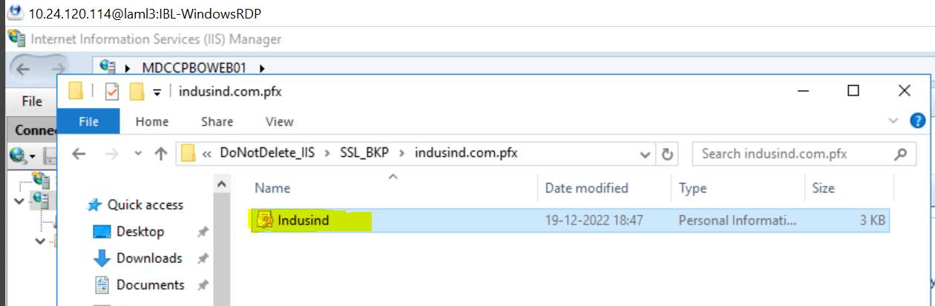

Click on Local machine than click on next.

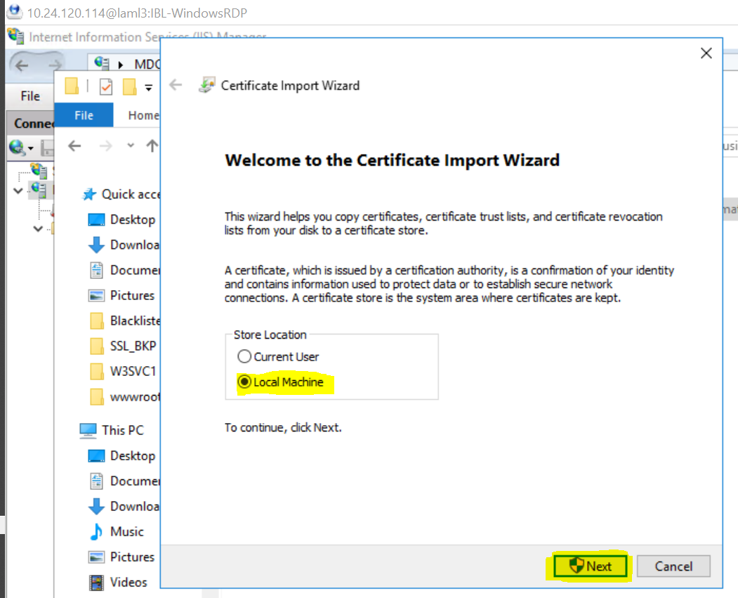

Click on next button.

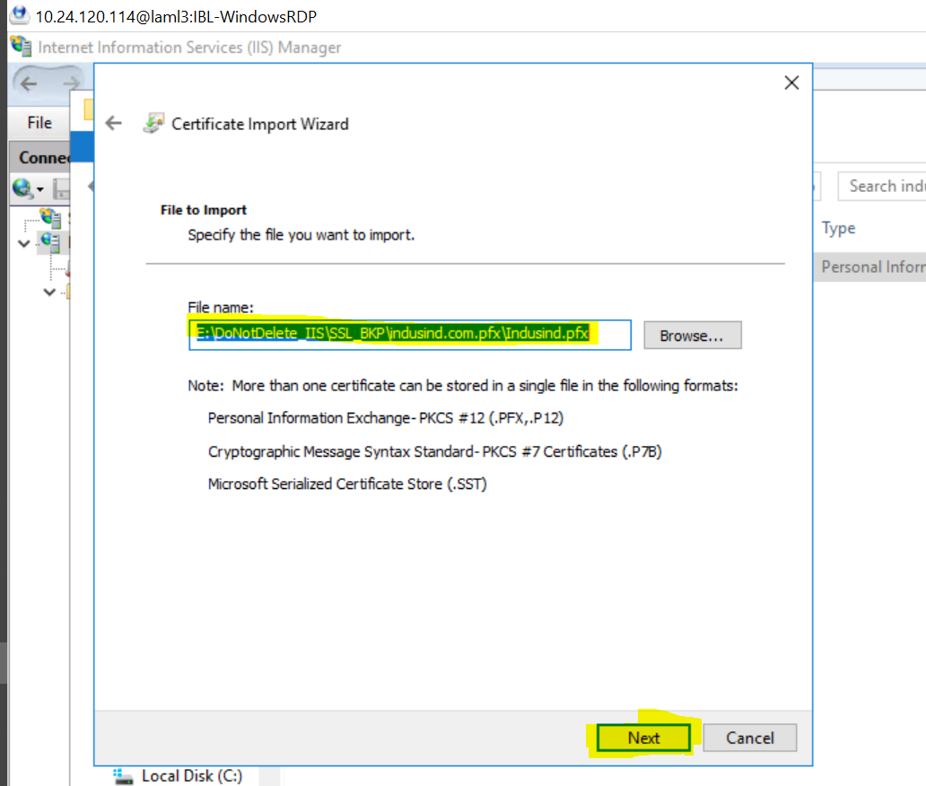

Enter the password and select the Mark this key as exportable than click on next button.

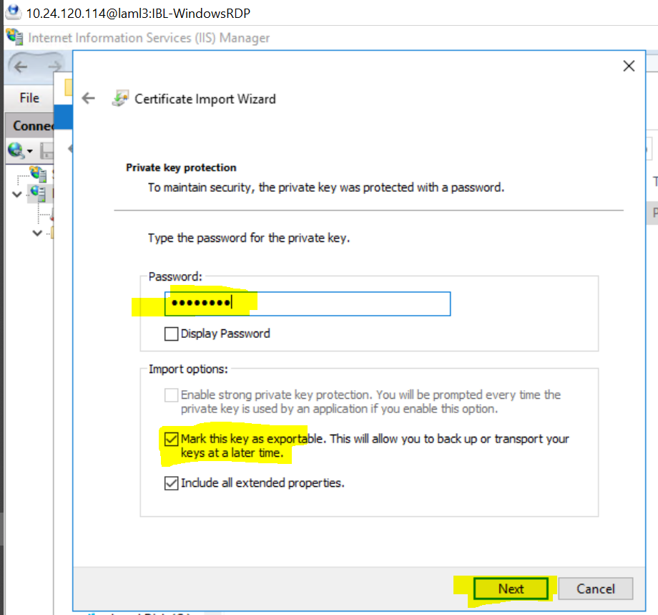

Click on next button.

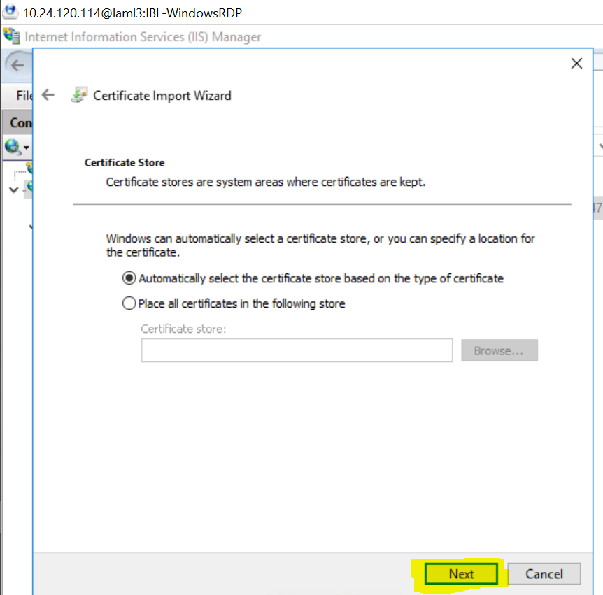

Click on finish Button.

